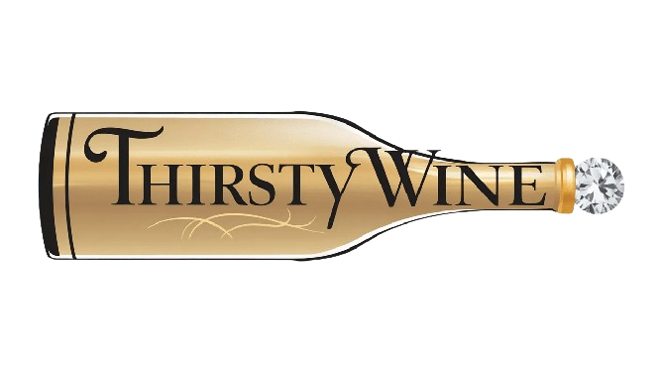
Test Summary Report
(Thirsty Wine)

Product Name | Thirsty Wine
Product Description | The Thirsty Wine Project is an online platform that allows users to explore, purchase, and learn about various wines. The website features an easy-to-navigate interface, with categories for different wine types such as red, white, and sparkling. Each product page provides detailed descriptions, including wine type, region, flavor profile, and pricing. Users can add wines to their cart, view their order history, and track deliveries through their personal accounts.You should login using the default administrator account :  - User Name : admin  - Password : admin
Project Description | <Mission of Project>  We conducted Testing to verify the Quality of the entire Thirsty Wine website functionality  Project Output  - Test Summary Report  - Bug/Defect Report
Project Type | Testing/Verification
Testing Functionality | Manual Testing,User Acceptance Testing,Functional Testing, Compatibility Testing, Usability Testing
Test Environment | Browser : Chrome,Safari,Firefox,Safari OS : Windows,Mac  Devices : Windows, Mac
Total Test Scenarios | 12
Total Test Cases | 137
Executed Test Cases | 75
Bugs Identified | 62
Project Duration | Start Date : 21/07/2025  End Date : 22-07-2025

